CO-MICC Data Portal: known issues

Last update on 01.12.2021.

Foreword

The CO-MICC Data Portal is a pilot portal, which means that it is still under development. This document compiles the list of known issues related to the portal. The issues are ordered into three categories:

- Model output data: this category comprises the issues related to the data sets computed with the global hydrological models (4 RCPs¹ x 4 GCMs² x 3 GHMs³ x 2 GHM variants = 96 data sets in total), which are used to compute the freshwater-related indicators available in the portal.
- Calculation and availability of indicators: this category groups the issues related to the indicator calculation based on model output data (this calculation is done on the run by the web application according to the options selected in the menu by the user).
- User interface: this category comprises the issues related to the appearance, display errors/artifacts and defective/missing functions of the user interface.

If you wish to report an issue that is not documented here, please contact us at icwrgc@bafg.de.

Known issues

Model output data

Some of the model output data sets, which are needed for the computation of the indicator data sets, need to be updated. The data sets in question are:

- All WaterGAP2.2d data sets corresponding to the PET-MD⁴ modelling scheme.

- All soil moisture data sets computed with LPJmL. Until this update is effective, the indicators derived from soil moisture data will not be available in the portal.

Calculation and availability of indicators

- For some of the variables, there is the option to compute annual and/or monthly low/high flows (Fig. 1). These statistics are calculated as percentiles. The current correspondence between menu labels and percentiles (Table 1) needs to be modified in order to correspond to the definition of high and low flows of Hattermann et al. (2018) (Table 2).

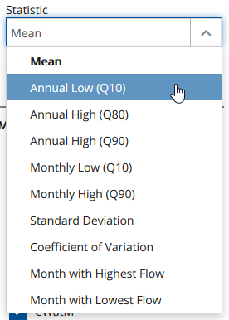
Figure 1: Annual and monthly high and low flow options in the “Statistic” drop-down menu.

Table 1: Current correspondence between labels in the “Statistic” menu and percentiles.
Option in “Statistic” menu | Corresponds to…
Annual low (Q10) | 90th percentile
Annual high (Q80) | 20th percentile
Annual high (Q90) | 10th percentile

Table 2: Correspondence between labels in the “Statistic” menu and percentiles after planned changes.
Option in “Statistic” menu | Corresponds to…
Annual low (Q80) | 80th percentile
Annual low (Q90) | 90th percentile
Annual high (Q10) | 10th percentile

- Water scarcity and water stress are both calculated as ratios. Concerning the water scarcity and water stress indicators, in addition to absolute changes (see “Modus” menu), there will also be the option to compute actual index values.

- Regarding annual actual evapotranspiration (AET) and potential evapotranspiration (PET), the options AET/precipitation and PET/precipitation will be added to the “Statistic” menu, respectively (Fig. 2).

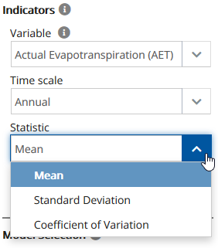
Figure 2: Current options in “Statistic” menu for annual actual evapotranspiration.

User interface

Appearance

- In the data viewer, the blue hue of the ocean is too similar to one of the blue hues included in the legend colour palette going from red to blue (Fig. 3). Since this can create visual confusion, the blue hue of the ocean will be replaced by a different one.

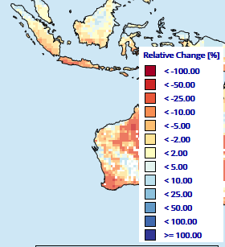
Figure 3: Comparison between the blue hue of the ocean and the blue hues of the legend colour palette going from red to blue.

- The appearance of the raster cell box (Fig. 4) will be improved (letter fonts and sizes, positioning of the elements, icons etc.).
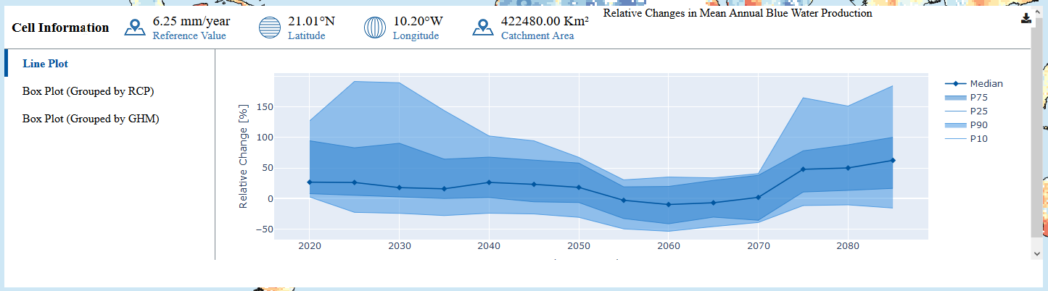
Figure 4: Current appearance of the raster cell box.

- The appearance of the information box that appears in the bottom right corner of the data viewer when hovering over the map (Fig. 5) will be improved.

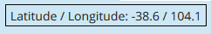
Figure 5: Current appearance of the information box that appears in the bottom right corner of the data viewer when hovering over the map.

Display errors and visual artifacts

- In some cases, the legend title and the values corresponding to the legend classes are not correctly displayed (Fig. 6).

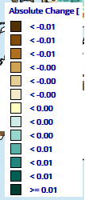
Figure 6: Legend display errors.

- Regarding relative changes in mean annual water availability, there is a bug that prevents the data from being displayed in basin aggregation mode.

- Regarding the raster cell box, some users have reported a display error as shown in Fig. 7.
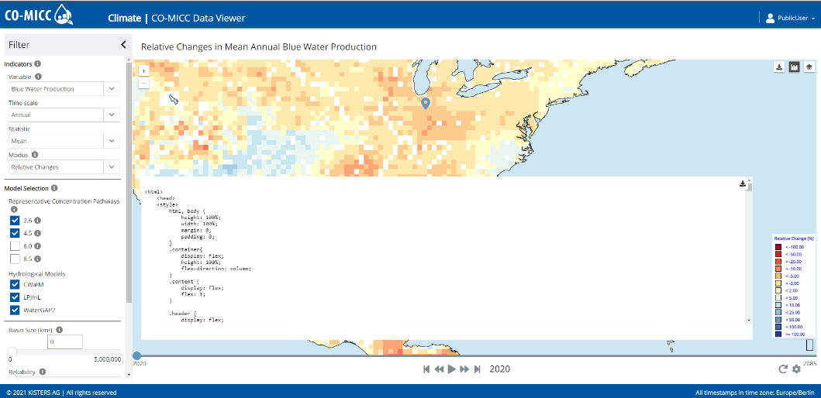
Figure 7: Display error of the raster cell box.

- There is a visual artifact in country aggregation mode that affects the border grid cells (Fig. 8). This is because these cells contain area belonging to more than one country. In the next release of the portal, this artifact will be removed by assigning each border cell to the country with the largest area.

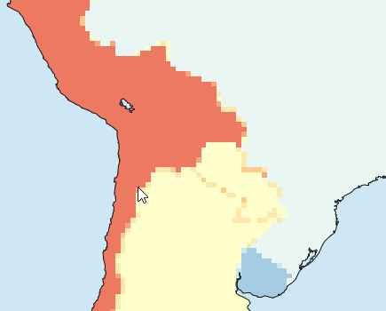
Figure 8: Visual artifact in country aggregation mode.

Defective and/or missing functions

- The download function is not working yet.

- The header of the raster cell box (Fig. 4) will not only give information on the catchment area, but also on the catchment name.

- In the next release of the portal, the “Reliability” slider will include a box to enter the value manually, like the “Basin Size” slider (Fig. 9).
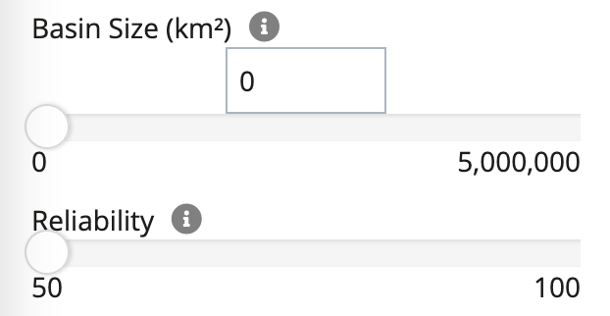
Figure 9: Sliders “Basin Size” and “Reliability”.

